# Description

This is the homework of the 2nd lecture.

# Task #1: CloudFormation CLI

## Question

Configure AWS credentials in your local laptop and use AWS CLI to create a cloudformation stack “CDN.yaml” in aws CLI command line.

Tips:

- Read and follow the guidelines in “Quickly Configuring the AWS CLI” section: https://docs.aws.amazon.com/cli/latest/userguide/cli-chap-configure.html.

- You will need to give CloudFormation and Cloudfront permissions. Or you can start with attach an “Admin” permission (security risk and anti-pattern).

$ aws cloudformation create-stack --stack-name myCDN --template-body file://CDN.yaml



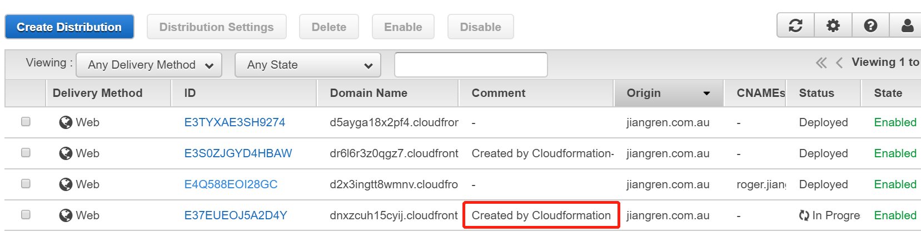

# Task 2: CloudFormation template to create route53

## Question

Develop a CloudFormation template to create route53 hostzone and DNS records. The expectation is that you will create a hosted zone and a DNS record in the route53 via this cloudformation template..

Tips:

- Create hosted zone: https://docs.aws.amazon.com/AWSCloudFormation/latest/UserGuide/aws-resource-route53-hostedzone.html

- Create recordset:

https://docs.aws.amazon.com/AWSCloudFormation/latest/UserGuide/aws-properties-route53-recordset.html

$ aws cloudformation create-stack --stack-name myDNS --template-body file://DNS.yaml



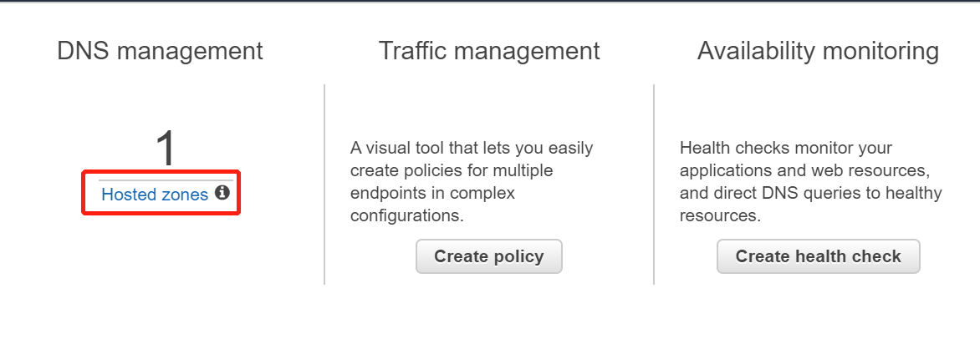

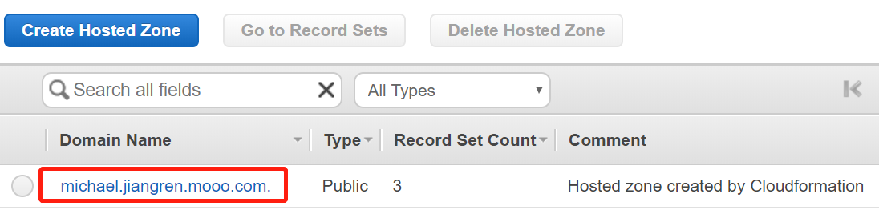

# Task #3: Apply a domain name (Optional)

## Question

Apply a domain name and play around

It can be a free sub-domain name or a free/paid TLD domain name.

Tips: try any of them or just search “Free domain name” in Google.

https://godaddy.com

https://onlydomains.com

https://namecheap.com

https://freedns.afraid.org (Free)

<https://www.freehao123.com/freedns-afraid-org/>

<https://www.youtube.com/watch?v=TBnxDnv9vlQ>

ausdream.mooo.com

